***Dt : 18/8/2022***

***Execution flow of DemoMethods2.java:***

***ClassFiles:***

***Average.class***

***DemoMethods2.class(MainClass)***

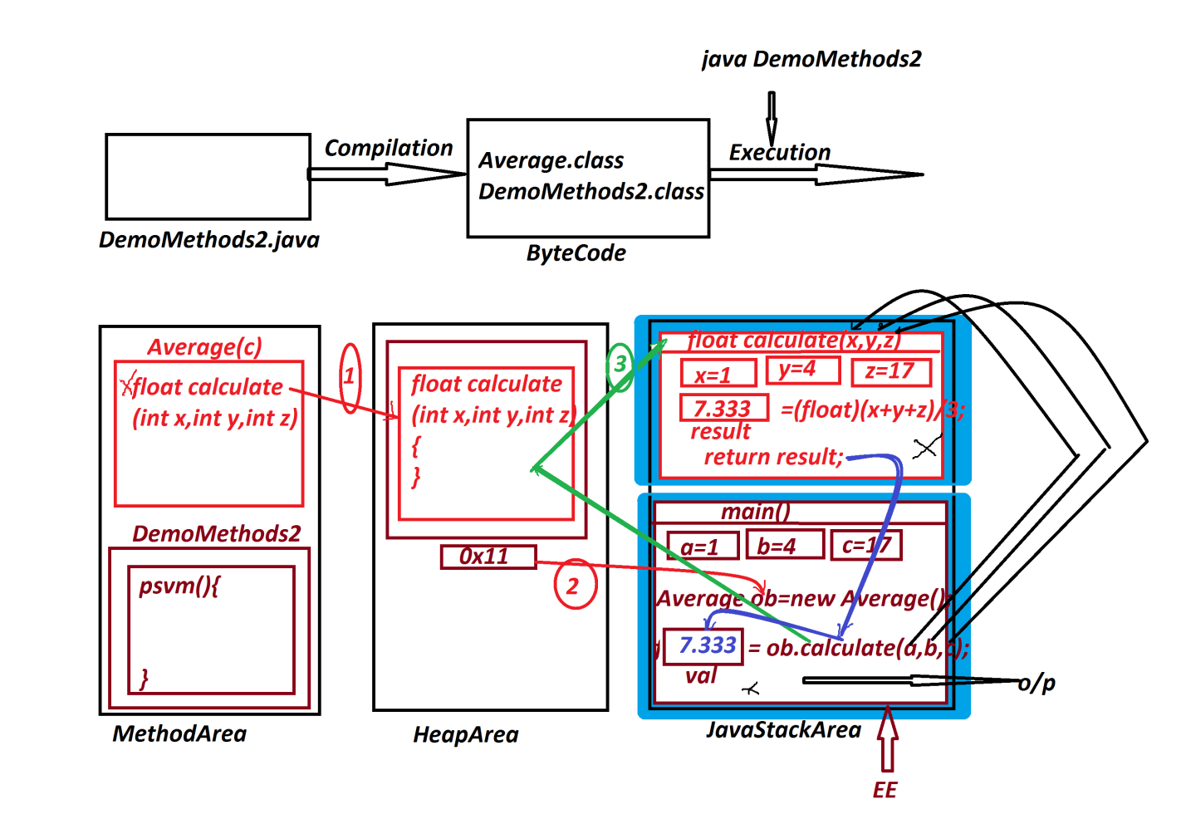

***======================================================***

***Note:***

***List of Variables : x,y,z,result,a,b,c,ob,val***

***List of Parameters : a,b,c,x,y,z***

***Actual Parameters : a,b,c***

***Formal Parameters : x,y,z***

***=>The parameters which are used to pass values while method***

***call are known as Actual Parameters.***

***=>The parameters which hold intermediate data while method***

***execution are known as Formal parameters.***

***(Parameters in Method Signature are known as Formal parameters)***

***=>we can take same names in Actual Parameters and Formal***

***Parameters.***

***======================================================***

***Note:***

***=>while execution process,MainClass is loaded onto MethodArea***

***first and then SubClass is loaded based on its requirement.***

***==========================================================***

***\*imp***

***Reading input to Java Programs:***

***=>we use Pre-defined 'Scanner' class from 'java.util' package***

***to read input to Java programs.***

***=>This 'Scanner' class is having the following some important***

***methods to read data to Java Programs:***

***1.nextByte()***

***2.nextShort()***

***3.nextInt()***

***4.nextLong();***

***5.nextFloat()***

***6.nextDouble()***

***7.nextBoolean()***

***8.nextLine()***

***=>All these Instance methods will get the memory within the***

***'Scanner' class object and can be accessed with Object_name.***

***syntax of Object creation for Scanner class:***

***Scanner s = new Scanner(System.in);***

***=>"System.in" in Java ,represents connecting OS-Buffer to***

***Scanner class object.***

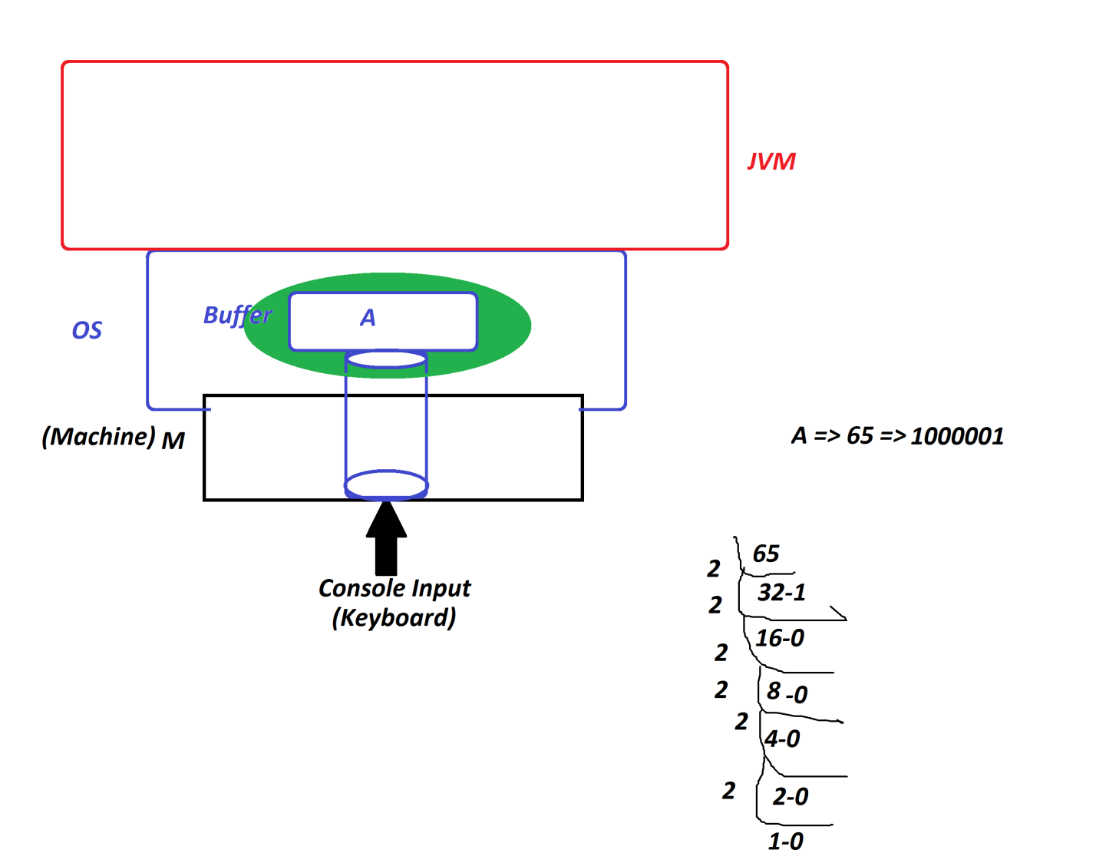

***----------------------------------------------------***

***Dt : 19/8/2022***

***syntax of methods:***

***1.nextByte(): This method is used to read byte data.***

***Method Signature:***

***public byte nextByte();***

***syntax:***

***byte val = s.nextByte();***

***2.nextShort(): This method is used to read short data.***

***Method Signature:***

***public short nextShort();***

***syntax:***

***short val = s.nextShort();***

***3.nextInt(): This method is used to read int data.***

***Method Signature:***

***public int nextInt();***

***syntax:***

***int val = s.nextInt();***

***4.nextLong(): This method is used to read long data.***

***Method Signature:***

***public long nextLong();***

***syntax:***

***long val = s.nextLong();***

***5.nextFloat(): This method is used to read float data.***

***Method Signature:***

***public float nextFloat();***

***syntax:***

***float val = s.nextFloat();***

***6.nextDouble(): This method is used to read double data.***

***Method Signature:***

***public double nextDouble();***

***syntax:***

***double val = s.nextDouble();***

***7.nextBoolean(): This method is used to read boolean data.***

***Method Signature:***

***public boolean nextBoolean();***

***syntax:***

***boolean val = s.nextBoolean();***

***8.nextLine(): This method is used to read String data.***

***Method Signature:***

***public String nextLine();***

***syntax:***

***String val = s.nextLine();***

***==========================================================***

***Ex:***

***wap to read and display user details(name,mailId,phoneNo)?***

***import java.util.Scanner;***

***class DemoMethods3***

***{***

***public static void main(String[] args)***

***{***

***Scanner s = new Scanner(System.in);***

***System.out.println("Enter the Name:");***

***String name = s.nextLine();//reading String data***

***System.out.println("Enter the MailId:");***

***String mailId = s.nextLine();//reading String data***

***System.out.println("Enter the PhoneNo:");***

***long phNo = s.nextLong();//reading long data***

***System.out.println("=====User Details=====");***

***System.out.println("UserName:"+name);***

***System.out.println("MailId:"+mailId);***

***System.out.println("PhoneNo:"+phNo);***

***}***

***}***

***o/p:***

***Enter the Name:***

***Raj Kumar***

***Enter the MailId:***

***raj@gmail.com***

***Enter the PhoneNo:***

***9898981234***

***=====User Details=====***

***UserName:Raj Kumar***

***MailId:raj@gmail.com***

***PhoneNo:9898981234***

***==================================================***

***Ex :***

***wap to read Six submarks and calcultae "totMarks and Percentage"?***

***import java.util.Scanner;***

***class TotalMarks //SubClass***

***{***

***int calculate(int s1,int s2,int s3,int s4,int s5,int s6)***

***{***

***return s1+s2+s3+s4+s5+s6;***

***}***

***}***

***class Percentage //SubClass***

***{***

***float generate(int totMarks)***

***{***

***return (float)totMarks/6;***

***}***

***}***

***class DemoMethods4 //MainClass***

***{***

***public static void main(String[] args)***

***{***

***Scanner s = new Scanner(System.in);***

***System.out.println("Enter the marks of subject-1:");***

***int sub1 = s.nextInt();***

***System.out.println("Enter the marks of subject-2:");***

***int sub2 = s.nextInt();***

***System.out.println("Enter the marks of subject-3:");***

***int sub3 = s.nextInt();***

***System.out.println("Enter the marks of subject-4:");***

***int sub4 = s.nextInt();***

***System.out.println("Enter the marks of subject-5:");***

***int sub5 = s.nextInt();***

***System.out.println("Enter the marks of subject-6:");***

***int sub6 = s.nextInt();***

***TotalMarks tm = new TotalMarks();***

***int totMarks = tm.calculate(sub1,sub2,sub3,sub4,sub5,sub6);***

***Percentage p = new Percentage();***

***float per = p.generate(totMarks);***

***System.out.println("=====Details====");***

***System.out.println("TotMarks:"+totMarks);***

***System.out.println("Percentage:"+per);***

***}***

***}***

***o/p:***

***Enter the marks of subject-1:***

***89***

***Enter the marks of subject-2:***

***98***

***Enter the marks of subject-3:***

***99***

***Enter the marks of subject-4:***

***90***

***Enter the marks of subject-5:***

***86***

***Enter the marks of subject-6:***

***82***

***=====Details====***

***TotMarks:544***

***Percentage:90.666664***

***===========================================================***

***Assignment:***

***wap to read and display Employee details with address?***

***(eId,eName,eDesg,hNo,sName,city,pinCode)***

***===========================================================***